**Project Development Phase**

Sprint-2 Create CloudantDB

|  |  |
| --- | --- |
| DATE | 5 NOV 2022 |
| TEAM ID | PNT2022TMID27630 |
| PROJECT NAME | Virtual Eye - LifeGuard For Swimming Pools  To Detect |
| MAXIMUM MARKS | 8 MARKS |

Register and Login To IBM Cloud:

1. Register with IBM cloud.
2. After Register, sign in with your credentials link.
3. Sign in with IBM id and Password .
4. IBM cloud dashboard will be created.

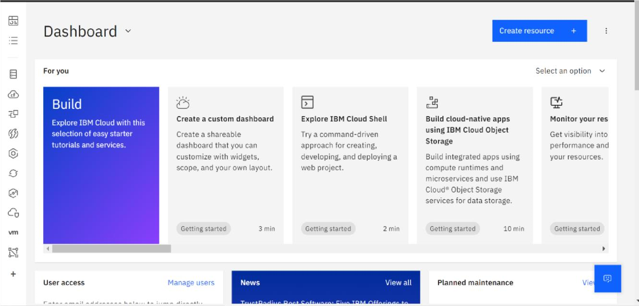

**Create Service Instance :**

1. Log in to your IBM Cloud account, and click on Catalog
2. Type Cloudant in the Search bar and click to open it.

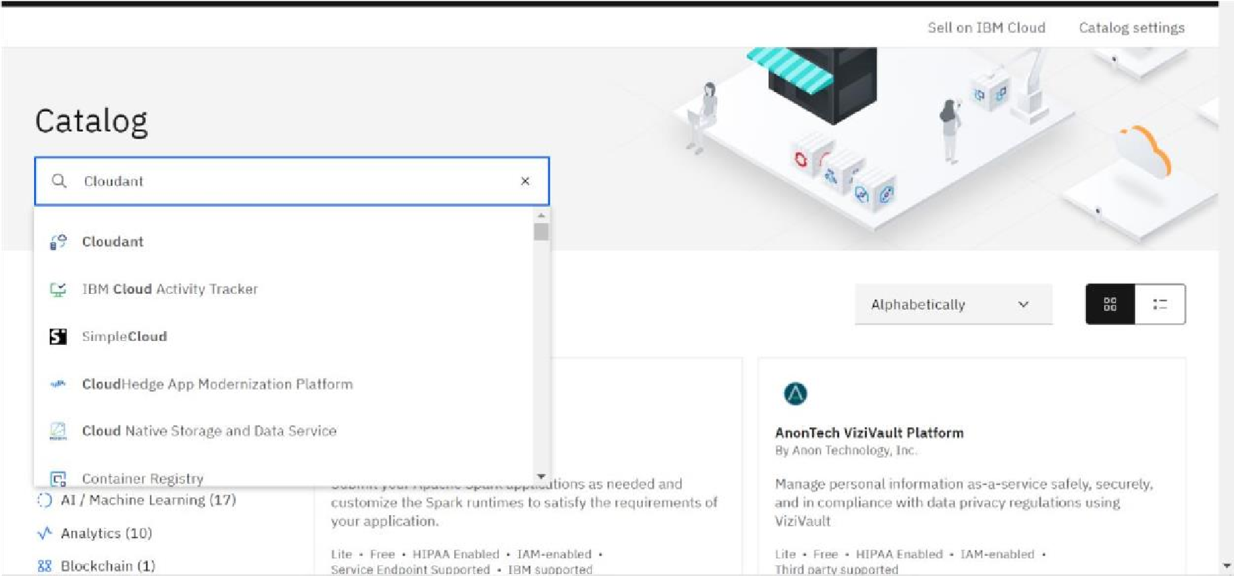

3.Select an offering and an environment

4.Select region as Dallas & Type an instance name then click on create service

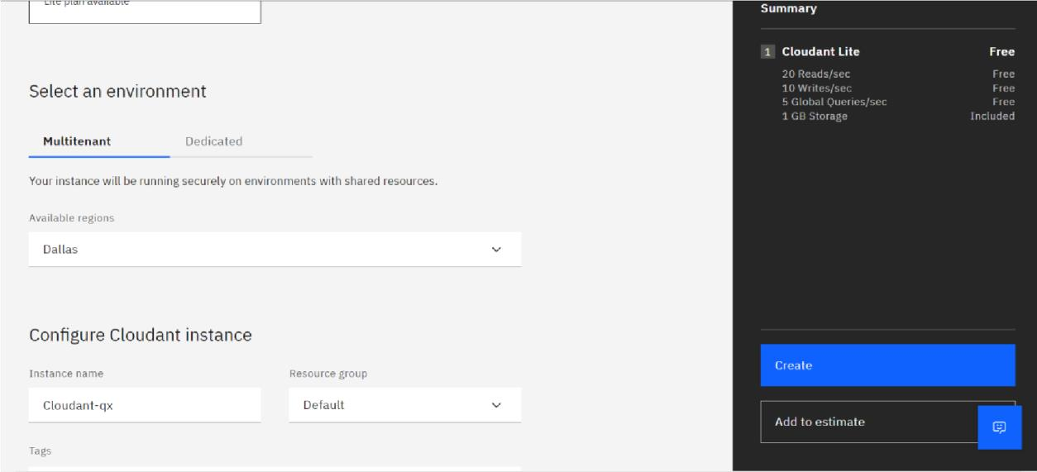

5.The status is changed to Active and then click the instance.

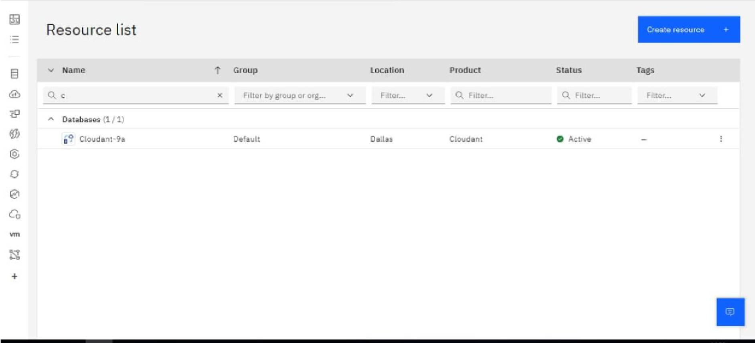

**Creating Service Credentials :**

1.Click Service credential and then click New credential.

2.Enter a name for the new credential in the Add new credential window.

3.Accept the Manager role

4.Click Add

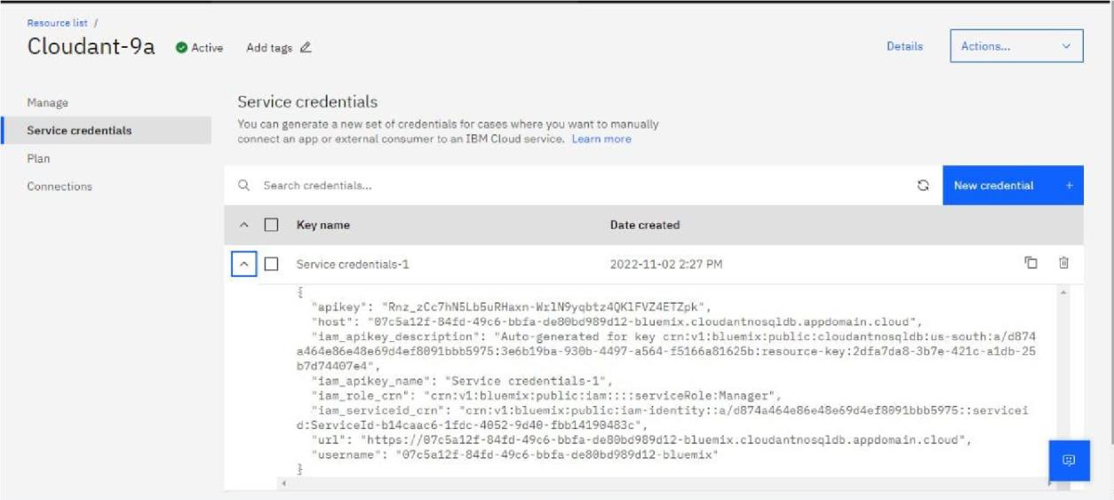

**Launch Cloudant DB :**

1.Launch Cloudant DB

2.Your Cloudant DB launches

3.Since new user a empty database is found

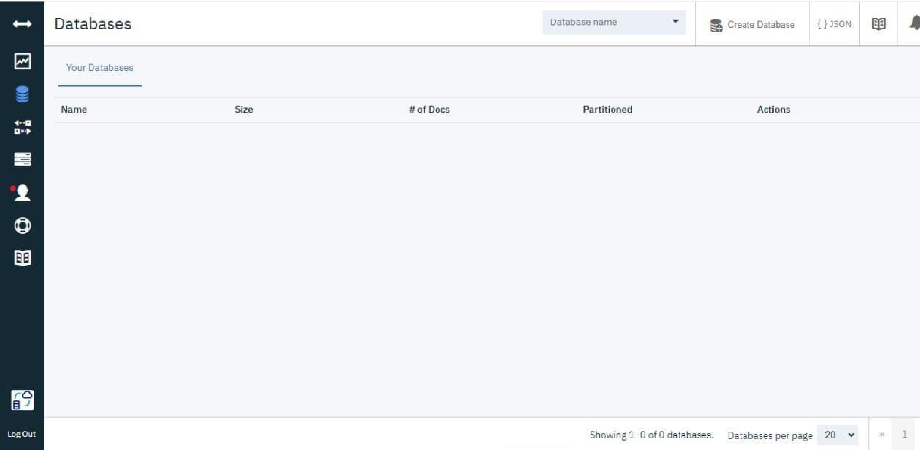

**Create Database :**

1.In order to manage a connection from a local system you must first initialise the connection by constructing a Cloudant client.We need to import the cloudant library.

2.we have to give username & apikey to build the connection with cloudant DB Once a connection is established you can then create a database, open an existing database.

3.Then create a database as my_database.

4.Database will be created